**Chapter15 The Put Writing Facility**

**1. The Syntax**

The basic structure of the put writing facility in its simplest form is :  
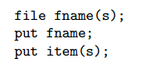

The first line defines the one or more files which you intend to write to. The second line assigns one of these defined files as the current file, that is the file to be written to. Lastly, the third line represents the actual writing of output items to the current file.

**2. An example**

The example will be based on the transportation model. The following program segment could be placed at the end of the transportation model to create a report:  
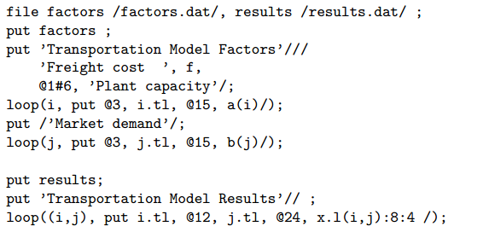

In the first line, the internal file names factors and results are defined and connected to the external file names factors.dat and results.dat.

The second line of this example assigns the file factors.dat as the current file, that is the file which is currently available to be written to.

In the third line of the example, writing to the document begins using a put statement with the textual item 'Transportation Model Factors'. Notice that the text is quoted. *The slashes following the quoted text represent carriage returns*(回车，一个斜杠表示一个回车). The example continues with another textual item followed by the scalar f. Notice that these output items are separated with commas. Blanks, commas, and slashes serve as delimiters for separating different output items. As mentioned above, the slash is used as a carriage return. *Commas and blank spaces serve as item delimiters*. These delimiters leave the cursor at the next column position in the document following the last item written. In most cases, the blank and the comma can be used interchangeably; however, the comma is the stronger form and will eliminate any ambiguities.

In the fifth line of the program above, the cursor is repositioned to *the first column of the sixth row* of the output file where another textual item is written. Lastly, the put statement is terminated with a semicolon.

Next，the parameters a and b are written along with their corresponding set labels. the put statement is embedded inside a loop which iterates over the index set. As can be seen, the set element labels are located starting in the third column and the parameter a at column 15. When executed, the factors.dat file will look like:

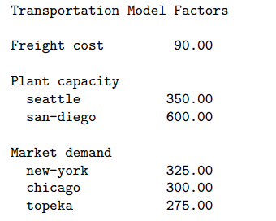

In the last two lines of the example, the file results.dat is made current and the values associated with the variable x along with their corresponding set element index labels are written line by line. The output results of the variable x are formatted by specifying a field width of eight spaces with four of these spaces reserved for the decimal. Notice that the local formatting options are delimited with colons. The results.dat file will look like:

